

Certificate of Training

### This is to certify that

### **FNAME LNAME**

### Has successfully completed

**COURSE**(CLPS Hours, CLPS CLPs)

**Location LOCATION Date START_DATE END_DATE**

Presented by

Business Management Research Associates, Inc.

9817 Godwin Drive, Suite 202  
Manassas, Virginia 20110

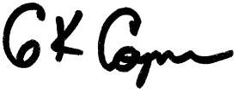

**___**

Gray Coyner

Owner & CEO